Figma Link

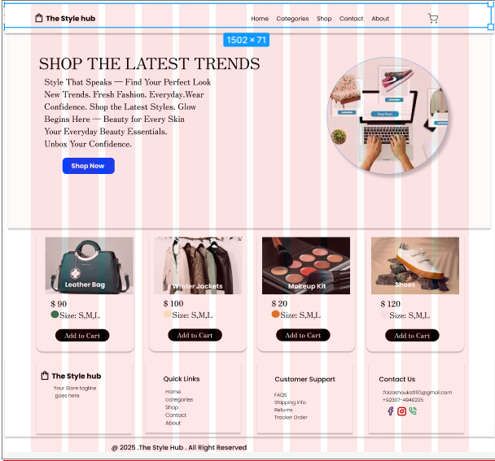
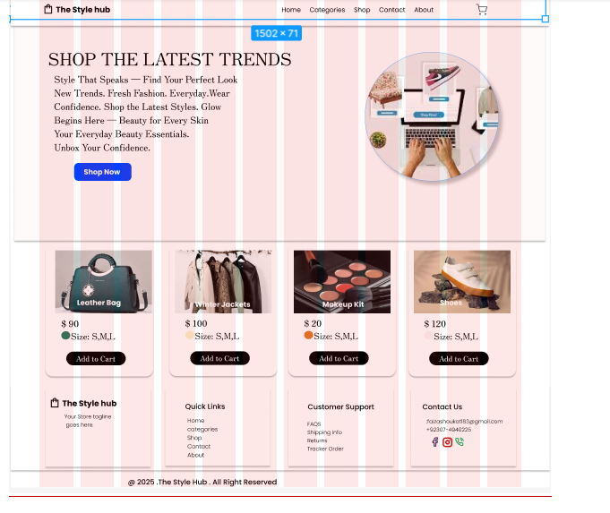
https://www.figma.com/design/9bv2BIYxkMsI9jJ7SP1JRE/ICT-PROJECT?node-id=0-1&p=f&t=LZF2gTyZAsGr4QDu-0
